

Report

**ON**

**FunCore**

***Project Report submitted in partial fulfillment of the requirements for the award of the***

***degree of***

**Bachelor of Technology**

**in**

**Computer Science and Engineering**

**(Hons.)**

Submitted By: Submitted To:

Name of Student: **Lucky Verma** **Mr. Garvit Dohere**

University Roll No.: **2115800014**

Name of Student: **Piyush Upadhyay**

University Roll No.: **2115800020**

Name of Student: **Vanshika Soni**

University Roll No.: **2115800030**

Department of Computer Engineering & Applications

**Institute of Engineering & Technology**

**DECLARATION**

We hereby declare that the project work entitled “**Funcore**” submitted to GLA University is a record of original work done by us, the group members, under the guidance of **Mr. Garvit Dohere.** This project work is submitted in partial fulfillment of the requirements for the award of the degree of Bachelor of Technology in Computer Science & Engineering (Honors). The results embodied in this thesis have not been submitted to any other University or Institute for the award of any degree or diploma.

|  |  |
| --- | --- |
| (Signature of Candidate) | (Signature of supervisor) |
|  |  |

i

**ACKNOWLEDGMENT**

It gives us great pleasure to present the report on the B.Tech major project undertaken during the B.Tech IV Year. This project reflects the inspiration, drive, and technical assistance provided by many individuals.

We owe a special debt of gratitude to Mr. Garvit Dohere, Associate Professor, GLA University Mathura, for providing us with an encouraging platform to develop this project. His constant support and guidance have been instrumental in shaping our abilities towards a constructive goal. His sincerity, thoroughness, and perseverance have been a constant source of inspiration. We believe that he will continue to shower us with his extensively experienced ideas and insightful comments at various stages of the project and also teach us about the latest industry-oriented technologies.

We also wish to acknowledge the contribution of all the faculty members of the department for their kind guidance and cooperation throughout the course of this project.

**Group Members**

**Name of Student: Lucky Verma**

**University Roll No.: 2115800014**

**Name of Student: Piyush Upadhyay**

**University Roll No.: 2115800020**

**Name of Student: Vanshika Soni**

**University Roll No.: 2115800030**

ii

**ABSTRACT**

The Funcore Gaming Platform is a comprehensive, scalable, and user-centric gaming solution designed to provide an engaging and immersive experience across a wide range of gaming genres. Built using the MERN stack (MongoDB, Express.js, React.js, Node.js) and enhanced with gaming frameworks like Phaser and PixiJS, Funcore offers both casual and complex gaming experiences with seamless integration of educational games. The platform emphasizes responsiveness, enabling optimal gameplay across devices, from desktops to mobile phones, and features a dynamic leaderboard that fosters competition.

Funcore integrates secure user authentication via Clerk, supports real-time data updates, and ensures smooth gameplay through Node.js and Express.js for backend operations. MongoDB facilitates flexible and scalable data storage, supporting the platform’s expansion with new games and features. The system also incorporates performance tracking, enabling users to monitor their progress and improve their gaming skills. By combining high-quality entertainment with educational content, Funcore bridges the gap between fun and learning, making it a valuable platform for all types of gamers. The architecture ensures scalability, data security, and ease of maintenance, positioning Funcore as a future-proof solution in the gaming industry.

iii

**CONTENTS**

Declaration ii

Acknowledgment iii

Abstract iv

**CHAPTER 1 Introduction 1**

1.1 Overview and Motivation 1

1.2 Objective 1

1.3 Summary of Similar Application 2

1.4 Organization of the Project 2

**CHAPTER 2 Software Requirement Analysis 4**

2.1 Introduction 4

2.2 Functional / Non Functional Requirements 4

2.3 Feasibility Analysis 5

2.4 Module Descriptions 6

2.5 Use Case Scenarios 6

2.6 Summary 7

**CHAPTER 3 Software Design 8**

3.1 Introduction 8

3.2 System Architecture 9

3.3 Component-Level Design 10

3.4 Data Flow Diagram (DFD) 11

3.5 Security Design 11

iv

3.6 User Experience Design (UX) 12

3.7 Summary 12

**CHAPTER 4 Implementation and User Interface 13**

4.1 Workflow 13

4.2 User Interface 15

**CHAPTER 5 Software Testing 19**

5.1 Introduction 19

5.2 Testing Objectives 19

5.3 Testing Methodologies 19

5.4 Test Cases 20

5.5 Result and Analysis 20

5.6 Conclusion 21

**CHAPTER 6 Conclusion 22**

6.1 Key Achievements

6.2 Challenges Addressed 22

6.3Future Prospects 23

**6.4 Final Remarks 23**

**CHAPTER 7 Summary 24**

**References**

**Appendices**

v

**Chapter 1**

**Introduction**

Chapter 1: Introduction

The first chapter provides an overview of the proposed system, including its motivation, objectives, a review of similar applications, and the structure of the project report. This chapter sets the stage for understanding the scope and purpose of the project, along with its intended impact on the educational and entertainment sectors.

**1.1 Overview and Motivation**

#### The Funcore Gaming Platform is an innovative initiative designed to enhance the online gaming experience by integrating entertainment, education, and user engagement. With the growing demand for dynamic and interactive platforms that provide personalized experiences, Funcore seeks to address these needs by offering a unified ecosystem that combines gaming, learning, and community engagement in one platform.

#### In the current gaming landscape, users often face fragmented ecosystems, where multiple platforms are needed to access different genres, educational content, or game features. This leads to an inconsistent user experience and divides developer resources across several systems. Funcore aims to eliminate these challenges by consolidating diverse functionalities into a single platform, improving accessibility and user engagement across various devices.

#### Funcore’s motivation stems from its potential to revolutionize gaming by not only offering a vast library of entertainment-focused games but also introducing educational games to help users develop essential skills through gamified learning experiences. By creating a comprehensive platform that is scalable, interactive, and educational, Funcore has the potential to redefine the gaming experience for users worldwide.

#### **1.2 Objective**

The **Funcore Gaming Platform** is designed to meet the following objectives, combining technology and user needs for an enhanced gaming experience:

1. **Unified Gaming Ecosystem :**

Provide a single platform with a variety of games, including both entertainment and educational options, to ensure consistent user engagement and easy access to different game types.

1. **Enhanced Engagement and Accessibility:**

Deliver a fully responsive design that adapts to various devices, ensuring that users can access and enjoy games on desktops, tablets, or smartphones with ease.

1. **Gamified Learning:**

Integrate educational games to combine entertainment with learning, catering to the growing demand for engaging, effective, and fun educational experiences.

1. **Immersive and Advanced Technology:**

Utilize frameworks like Phaser, PixiJS, and Three.js to deliver stunning 2D and 3D game visuals, providing users with a captivating and dynamic gaming experience.

1. **Scalability and High Performance:**

Use the MERN stack (MongoDB, Express.js, React.js, Node.js) to build a platform that can handle growing user traffic, ensuring smooth performance even as the platform expands.

1. **User Engagement Features:**

Incorporate leaderboards, performance tracking, and personalized dashboards to motivate players, provide tailored game recommendations, and foster community interaction.

1. **Secure Payment Integration:**

Enable seamless, secure transactions through Stripe for in-game purchases, subscriptions, and premium content, ensuring user trust and convenience.

1. **Analytics for Improvement:**

Leverage data analytics to monitor user behavior, optimize game offerings, and refine the platform’s features for continuous improvement.

By meeting these objectives, Funcore provides a comprehensive and adaptable solution for users, blending entertainment and education while staying at the forefront of the evolving gaming industry.

**1.3 Summary of Similar Application**

#### The Funcore Gaming Platform is distinct from traditional gaming platforms by combining entertainment and education within one ecosystem. It offers a diverse collection of games, from action-packed games to educational ones that enhance cognitive skills. Using frameworks like Phaser and PixiJS, Funcore provides visually engaging 2D and 3D games while ensuring smooth performance across devices through its responsive design powered by Next.js and Tailwind CSS.

#### The platform also integrates key features like leaderboards, performance tracking, and social interaction to encourage user engagement and competition. The educational component of Funcore distinguishes it by offering games that foster learning in areas such as problem-solving, logic, and cognitive development.

#### Funcore’s backend infrastructure, built with Node.js and MongoDB, ensures scalability and supports secure payment processing through Stripe, alongside robust user authentication via Clerk. Data analytics are employed to refine the user experience, adapt to user preferences, and continually improve the platform’s offerings. With a roadmap that includes expansions into 3D gaming and adaptive controls, Funcore is positioned to remain a leader in both the gaming and educational gaming sectors.

#### **1.4 Organization of the Project Report**

The remainder of this project report is organized as follows:

**Chapter 2: Software Requirement Analysis**

This chapter outlines the comprehensive process of gathering and analyzing the specific requirements for the Funcore platform. It includes a feasibility analysis, assessing technical, operational, and economic factors, and describes the platform’s modules, their functionalities, and use cases. This chapter ensures that the platform’s features align with user needs and expectations.

**Chapter 3: Software Design**

This chapter provides a detailed design of the system, including data flow diagrams to represent how data moves within the platform. UML diagrams are included to visualize the structure and behavior of the system. The chapter also outlines the database schemas, detailing the organization of data within MongoDB.

**Chapter 4: Implementation and User Interface**

This chapter focuses on the actual implementation of the platform, explaining the coding practices and technologies used, such as Node.js, Express.js, Phaser, PixiJS, and React.js. It also showcases the user interface (UI) design, providing screenshots and descriptions of key UI components to illustrate the user experience.

**Chapter 5: Conclusion**

This chapter summarizes the achievements and findings of the project, evaluating how well the objectives were met. It also discusses the potential impact of Funcore on both the gaming and educational sectors and suggests areas for future research and development.

**Chapter 6: Summary**

This final chapter provides a concise overview of the entire project, recapping the key points and outcomes. It serves as a quick reference to understand the scope, objectives, methodologies, and impact of the Funcore platform on the gaming and educational sectors.

**Bibliography**

This section lists all the references and resources used throughout the project, including academic papers, books, and online resources, serving as a foundation for further exploration of the topics discussed.

**Appendices**

The appendices contain supplementary materials, such as code snippets, additional diagrams, installation instructions, and user guides. These resources provide additional insights into the technical implementation of the Funcore platform and ensure that readers have all necessary information to understand and utilize the project effectively.

**Chapter 2**

**Software Requirement Analysis**

### **2.1 Introduction**

This chapter outlines the software requirements, feasibility studies, and detailed analysis necessary for the development of Funcore, an integrated gaming platform blending entertainment and education. The primary goal is to identify the essential components to ensure the platform's functionality, usability, scalability, and its ability to engage a wide range of users.

This section presents both technical and functional requirements that the platform must meet. It includes user roles, system interactions, and performance metrics that will guide the development process. By clearly defining these requirements, we ensure that the project aligns with the needs of gamers, developers, and educational institutions.

A thorough feasibility study assesses the practicality of the project in terms of technical, operational, and economic factors. The technical feasibility focuses on evaluating the technology stack and infrastructure that supports Funcore. Operational feasibility considers how the platform will be integrated into existing gaming ecosystems. Economic feasibility assesses the costs and potential returns on investment, ensuring financial viability.

This chapter also analyzes the various modules that will make up Funcore’s gaming ecosystem. Each module is examined for its functionality, interdependencies, and contribution to the overall system. The aim is to identify challenges early on and ensure all components work together effectively.

By addressing these areas systematically, this chapter lays the foundation for the subsequent development phases of Funcore, ensuring a strong base for creating a platform that delivers a comprehensive and engaging gaming experience.

### **2.2 Functional Requirements**

The functional requirements describe what Funcore is expected to do. For the Funcore platform, these include:

1. **Game Library Management**
   * Provide a diverse selection of games, both educational and entertainment-focused.
   * Enable users to explore games based on categories, such as genre, difficulty, or educational content.
   * Offer dynamic updates and new game releases.
2. **Interactive User Engagement**
   * Display leaderboards, achievements, and game performance tracking.
   * Allow for multiplayer features and interaction with other players in real-time.
   * Provide recommendations based on user behavior and preferences.
3. **Educational Content Integration**
   * Include educational games aimed at enhancing cognitive skills.
   * Allow educators to create personalized learning experiences within games.
   * Include AI-powered systems to adapt game content to player skill levels and learning objectives.
4. **Gamified Learning Features**
   * Enable users to track their progress across different games.
   * Generate quizzes and educational content that integrates with gameplay.
   * Provide feedback on performance in educational games to enhance the learning process.
5. **Payment Integration**
   * Offer in-game purchases for premium features.
   * Support subscription models for accessing exclusive content and games.
   * Integrate secure payment options through Stripe for easy transactions.
6. **Cross-Platform Accessibility**
   * Support various devices, including desktops, mobile phones, and tablets.
   * Ensure the platform adapts to different screen sizes and input methods for accessibility.

**2.3 Feasibility Analysis**

**1. Technical Feasibility**

**The technical feasibility of Funcore is supported by the use of modern web development technologies, including Next.js, React, and Node.js, enabling the creation of a responsive and dynamic platform. On the backend, MongoDB and Node.js ensure seamless data storage and handling, while Phaser, PixiJS, and Three.js provide the game engine for interactive gaming experiences. Integration with Stripe for payments and Clerk for secure authentication ensures smooth and secure user management.**

**2. Economic Feasibility**

**The economic feasibility of Funcore is reinforced by the choice of open-source technologies that reduce initial development costs. By using scalable cloud services, the platform can expand its user base without significant infrastructure costs. Moreover, the subscription model and in-game purchases generate ongoing revenue, which supports long-term sustainability.**

**3. Operational Feasibility**

**Funcore is designed to be user-friendly, catering to both gamers and educators. The platform’s ease of use, combined with personalized dashboards and educational tools, ensures that users can access and utilize the system with minimal effort. Regular updates and enhancements will keep users engaged while providing value to educational institutions by offering gamified learning experiences.**

**4. Schedule Feasibility**

**The agile development approach will ensure that Funcore delivers its core features on time, with iterative updates based on user feedback. By incorporating user stories and feedback loops, the development process will remain flexible to evolving requirements, enabling the platform to meet timelines and align with user needs.**

### **2.4 Module Descriptions**

### **1. User Management Module**

### **This module handles user registration, authentication, and access control. It supports multiple user roles, including casual gamers, competitive players, and educators. It also tracks user preferences and activity, enabling personalized game recommendations**

### **2. Game Engine Module**

### **The game engine module utilizes Phaser and PixiJS for 2D games and Three.js for 3D games. This module ensures dynamic and engaging gameplay experiences, including multiplayer features and real-time game updates.**

### **3. Educational Content Module**

### **This module integrates AI-powered educational games and allows users to create custom learning experiences. It includes tools for teachers to develop personalized lesson plans and quizzes integrated into games.**

### **4. Leaderboard and Engagement Module**

### **This module enables users to engage with the platform via leaderboards, achievements, and performance tracking. It fosters competition and social interaction among players, motivating them to improve their skills.**

### **5. Payment Integration Module**

### **This module handles secure transactions for in-game purchases and subscriptions, ensuring that premium content is easily accessible to users.**

**6. Analytics and Reporting Module**

The analytics module tracks user behavior, game performance, and educational outcomes. It helps developers optimize the user experience based on data-driven insights and monitor the success of educational games.

### **2.5 Use Case Scenarios**

1. **Scenario 1: Game Selection and Play**
   * **Actors**: User, Game Engine
   * **Steps**:
     1. The user logs into the platform.
     2. They browse the game library and select a game based on personal interests or educational goals.
     3. The user plays the game, interacting with the content and tracking performance.
     4. The game updates dynamically, providing real-time feedback and engagement metrics.
2. **Scenario 2: Course Creation for Educators**
   * **Actors**: Educator, AI System
   * **Steps**:
     1. The educator selects the "Create Course" option within the platform.
     2. They define topics, objectives, and difficulty levels.
     3. The AI generates course content, including educational games, quizzes, and assignments.
     4. The educator customizes the content and finalizes the course for use.
3. **Scenario 3: Payment and Subscription Management**
   * **Actors**: User, Payment System
   * **Steps**:
     1. The user opts for premium content or a subscription plan.
     2. They provide payment information through Stripe integration.
     3. The system processes the transaction, and the user gains access to premium features.

### **2.6 Summary**

This chapter provides a comprehensive analysis of Funcore’s software requirements and feasibility study. By outlining the functional and non-functional requirements, feasibility analyses, and module descriptions, we ensure the platform’s foundation is solid for development. The defined use case scenarios help clarify the key user interactions and workflows, paving the way for successful implementation and user engagement in the next development phases.

**Chapter 3**

**Software Design**

**3.1 Introduction**

This chapter focuses on the architectural and design elements that form the foundation of **Funcore**. System design bridges the gap between the conceptualization of requirements and their technical implementation. Key components include:

1. **System Architecture** The system architecture outlines the overall structure of **Funcore**, defining how different components interact and function together. It typically follows a layered architecture model, which may include:

* **Presentation Layer**: The user interface built using modern frameworks like Next.js and React, providing an intuitive experience for course creators, learners, and administrators.
* **Application Layer**: The core logic of the platform, including modules for course creation, user management, learner analytics, and content generation.
* **Data Layer**: Responsible for data storage and retrieval, utilizing Drizzle ORM and Firebase to manage backend operations efficiently.

1. **Module Interaction** The interaction between various modules is crucial for seamless functionality. Key interactions include:

* **User Management Module**: Works with the **Course Generation Module** to personalize course recommendations based on user roles, progress, and learning goals.
* **Course Generation Module**: Collaborates with the **Analytics and Reporting Module** to provide insights into course content effectiveness and learner engagement.
* **Collaboration Module**: Integrates with the **Course Generation Module**, allowing multiple users to edit and update course materials collaboratively, with version control and live updates.

1. **Data Flow** Understanding data flow is essential for optimizing performance and ensuring data integrity. The data flow can be summarized as follows:

* **Input**: Users input details for course creation, including course objectives, topic, and learner profiles.
* **Processing**: The AI generates course content, quizzes, multimedia, and assignments, which are then stored in the database.
* **Output**: Finalized course content is made available to users, along with learner performance analytics and engagement insights.

1. **Database Schema** The database schema defines how data is organized within the system. It includes:

* **User Table**: Stores user information, roles (course creators, learners, administrators), preferences, and progress.
* **Course Table**: Contains details about each course, including title, objectives, lessons, multimedia elements, and quizzes.
* **Assessment Table**: Manages quizzes, assignments, and assessments, linking them to their respective courses.
* **Collaboration Table**: Tracks collaborative efforts, such as version control and contributions from multiple educators.

This architectural framework ensures that **Funcore** is scalable, flexible, and capable of delivering a high-performance user experience.

**3.2 System Architecture**

Three-Tier Architecture of Skill Forge AI

**Funcore** employs a three-tier architecture that enhances the system's scalability, maintainability, and performance. Each layer plays a crucial role in delivering a seamless user experience and robust functionality.

**1. Presentation Layer (Frontend)**

- Technologies Used:

* + **React**: Provides a dynamic, component-based interface for real-time interactions.
  + **Tailwind CSS**: Ensures a responsive design with utility-first CSS classes.
  + **Next.js**: Facilitates efficient rendering through:
    - **Server-Side Rendering (SSR)**: Improves SEO and performance by generating pages on the server.
    - **Static Site Generation (SSG)**: Enhances load times by pre-rendering pages at build time.
* **Rendering Features**:
  + **React** and **Next.js** enable optimized front-end rendering with seamless interactivity, ensuring a smooth and engaging experience for course creators and learners alike.

**2. Application Layer (Backend)**

* Core Technology:
* **Node.js**: Powers the backend with a non-blocking, event-driven architecture.
* Functionality:
* API Gateway: Routes requests between the frontend and backend efficiently, ensuring data security and proper functionality.
* Content Generation APIs: Manage the generation of courses, quizzes, and assignments based on AI-driven algorithms, including integration with the Gemini AI API for adaptive content creation.

**3. Data Layer**

* - **Hosting and Services**:
  + **Firebase**: Provides real-time updates, user authentication, and secure data storage.
* **Database Structure**:
  + **Structured Databases**: Used for storing user profiles, course metadata, and assessments.
  + **Unstructured Databases**: Accommodate dynamic content like course material, multimedia, and learner-generated data.

This three-tier architecture of **Funcore** ensures that the system is efficient, scalable, and robust, providing users with a high-quality experience.

**3.3** **Component-Level Design**

**3.3.1 User Interface Components**

1. **Dashboard**
   * Displays course creation status, learner progress, and performance metrics.
   * Features drag-and-drop functionality for editing course structure and rearranging content.
2. **Course Editor**
   * Allows course creators to customize AI-generated content, modify lesson structure, and integrate multimedia resources.
   * Supports real-time preview to ensure courses are tailored to teaching needs.
3. **AI Chat Assistant**
   * Provides conversational support for users during course creation, offering guidance on structuring content or adjusting course settings.
   * Accessible from any page within the platform for real-time assistance.

**3.3.2 Backend Components**

1. **API Gateway**
   * Routes requests between the frontend and backend.
   * Manages user authentication and ensures smooth interaction with external APIs (e.g., Gemini AI for content generation).
2. **AI Processing Engine**
   * Integrates the **Gemini API** for intelligent course creation, providing adaptive learning content based on user input and learner behavior.
   * Includes a feedback loop for refining AI outputs based on user customization.
3. **Collaboration Module**
   * Implements version control to track changes made by different users, ensuring transparent and accountable collaboration.
   * Manages permissions for multi-user collaboration in course development.

**3.4 Data Flow Diagram (DFD)**

**3.4.1 Context Diagram (Level 0)**

This diagram shows the interaction between:

* **Users (Educators, Learners, Admins)**: Interact with the **Funcore** platform.
* **Funcore System**: Processes inputs, generates content, tracks learner progress, and outputs content and data.
* **External Systems**: Connects with external systems like Learning Management Systems (LMS), third-party APIs, and cloud storage for enhanced functionality.

**3.4.2 Detailed Diagram (Level 1)**

Key processes include:

* **User Authentication**:
  + User logs in → Credentials verified → Access granted based on role.
* **Course Creation**:
  + Educator provides course details → AI generates content → User customizes → Course finalized.
* **Data Management**:
  + Save course details → Sync updates with Firebase → Export to LMS.

**3.5 Security Design**

1. **Authentication and Authorization**
   * Role-based access control (RBAC) ensures that only authorized users (course creators, administrators, learners) access certain functionalities.
   * Firebase Authentication provides secure login mechanisms with multi-factor authentication (MFA) support.
2. **Data Security**
   * **AES Encryption** for sensitive data at rest and **SSL/TLS** protocols for secure data transmission ensure that user data is protected during transfer and storage..
3. **Backup and Recovery**
   * Regular backups are stored in cloud services to ensure data continuity in case of system failures or breaches.
4. **API Security**
   * OAuth2.0 and API Keys ensure that third-party services can securely communicate with **Funcore**.
   1. **User Experience Design (UX)**
5. **Simple Navigation**

* Intuitive UI with breadcrumbs, tooltips, and contextual menus to guide users throughout the platform.

1. **Responsive Design**

* Ensures optimal viewing and interaction across devices (mobile, tablet, desktop) using **Tailwind CSS**.

1. **Accessible Design**
   * Complies with Web Content Accessibility Guidelines (WCAG).

**3.7 Summary**

The system design for Funcore has been carefully crafted to combine scalability, security, and usability. The platform is designed to:

**Scalability**: Handle growing user demands and complex features with ease.

**Security**: Ensure data integrity and privacy with strong encryption, authentication, and regular backups.

**Usability**: Provide an intuitive and accessible platform for educators, administrators, and learners.

This foundational design ensures that Funcore delivers an efficient, future-proof solution for personalized learning course creation and management, fostering continuous improvement in the education space.

**Chapter 4**

**Implementation and User Interface**

4.1 Workflow

#### The workflow of Funcore is designed to streamline the process of creating and managing personalized learning content in a simple and intuitive way. The following steps describe the complete workflow:

**Step 1: User Login and Authentication**

* **Purpose**: Ensure secure access to the platform.
* **Process**:
  + Users log in or sign up using their credentials (email/password or OAuth2.0 authentication methods like Google or Facebook).
  + The system verifies credentials and provides access to the dashboard. If the user is new, they are prompted to complete their profile setup.

**Step 2: Selecting Course Category**

* **Purpose**: Allow users to choose the domain or area of interest for course generation.
* **Process**:
  + Users select a predefined category based on their teaching or learning preferences, such as:
    - **Programming** (e.g., Python, JavaScript, Java)
    - **Health** (e.g., Nutrition, Fitness, Mental Health)
    - **Business** (e.g., Marketing, Finance, Entrepreneurship)
    - **Creativity** (e.g., Photography, Design, Music)
    - **Custom Categories**: Users can define their own topics, enabling flexibility.

**Step 3: Providing Course Details**

* **Purpose**: Capture user inputs to generate a personalized course.
* **Process**:
  + Users fill in the following parameters to define the structure of the course:
    1. **Course Title**: Name of the course (e.g., "Introduction to JavaScript").
    2. **Description**: A brief overview of the course goals and objectives.
    3. **Difficulty Level**: Select from Beginner, Intermediate, or Advanced based on the target audience.
    4. **Course Duration**: Specify total course duration (e.g., 4 weeks, 10 hours).
    5. **Number of Chapters**: Define how many chapters the course should include.
    6. **Additional Features**: Options to include quizzes, assignments, and recommended video resources.
    7. **Learning Outcomes**: Specify key skills or outcomes learners will achieve upon completing the course.

**Step 4: Course Generation using Gemini AI**

* **Purpose**: Generate structured, personalized course content based on user inputs.
* **Process**:
  + The user submits the course details.
  + The system uses **Gemini AI** to design a customized course, including:
    - **Chapter Breakdown**: Detailed structure with topics for each chapter.
    - **Structured Content**: The AI organizes content into lessons, subtopics, and key points.
    - **Quizzes and Assignments** (if opted): Automatically generates quizzes and assignments aligned with each chapter's content.
    - **Video Resources** (if opted): Suggestions for relevant video resources (e.g., YouTube links) to enhance learning.
  + The generated course is then displayed on the user’s dashboard, where it can be reviewed and further customized.

**Step 5: Customization of the Generated Course**

* **Purpose**: Allow users to fine-tune the generated course and adapt it to their specific needs.
* **Process**:
  + Users can:
    - **Modify the Number of Chapters**: Add or remove chapters as needed.
    - **Edit Chapter Content**: Modify any section, add custom text, change lessons, or insert new material.
    - **Add/Remove Quizzes and Assignments**: Option to add, remove, or modify quizzes and assignments based on the course content.
    - **Change Learning Outcomes**: Adjust learning outcomes to match specific goals for learners.
  + As users make changes, the system dynamically updates the course content, reflecting the real-time adjustments made.

**Step 6: Course Review and Publishing**

* **Purpose**: Finalize the course before it is made available for learners.
* **Process**:
  + Users review the final version of the course, ensuring that all details (content, quizzes, assignments) are correct.
  + A **Preview Mode** allows users to view the course as a learner would, ensuring everything flows logically and intuitively.
  + After final approval, users can publish the course to the **Funcore** platform, making it available for learners or for use in private teaching.

**Step 7: Subscription Management**

* **Purpose**: Manage course generation limits and subscriptions.
* **Process**:
  + Users can create up to 5 courses for free. Once the limit is reached, the system prompts users to subscribe for unlimited course creation capabilities.
  + Subscriptions are managed through a seamless payment gateway, enabling users to select a payment plan that suits their needs. Plans may include monthly, annual, or pay-as-you-go options.
  + Users can upgrade, downgrade, or cancel their subscription directly from their dashboard, with any changes reflected in real-time.

**Step 8: Learner Enrollment and Engagement**

* **Purpose**: Allow learners to access courses and track their progress.
* **Process**:
  + Users (learners) can browse and enroll in published courses.
  + Upon enrollment, learners can:
    - **Track Progress**: Monitor their progress through the course, seeing completed chapters, quizzes, and assignments.
    - **Engage with Content**: Participate in quizzes, assignments, and interact with multimedia content such as videos and supplementary resources.
    - **Receive Feedback**: Quizzes and assignments can be graded automatically, with feedback provided to enhance learning.

**Step 9: Analytics and Reporting**

* **Purpose**: Provide course creators with insights into course performance and learner engagement.
* **Process**:
  + The system generates detailed **analytics reports** showing:
    - **Learner Progress**: Overview of how learners are performing in the course (completion rates, quiz scores, etc.).
    - **Course Effectiveness**: Data on how well the course content is resonating with learners (engagement metrics, feedback scores, etc.).
    - **Learner Feedback**: Aggregate feedback from learners on course content, structure, and user experience.

4.2 User Interface

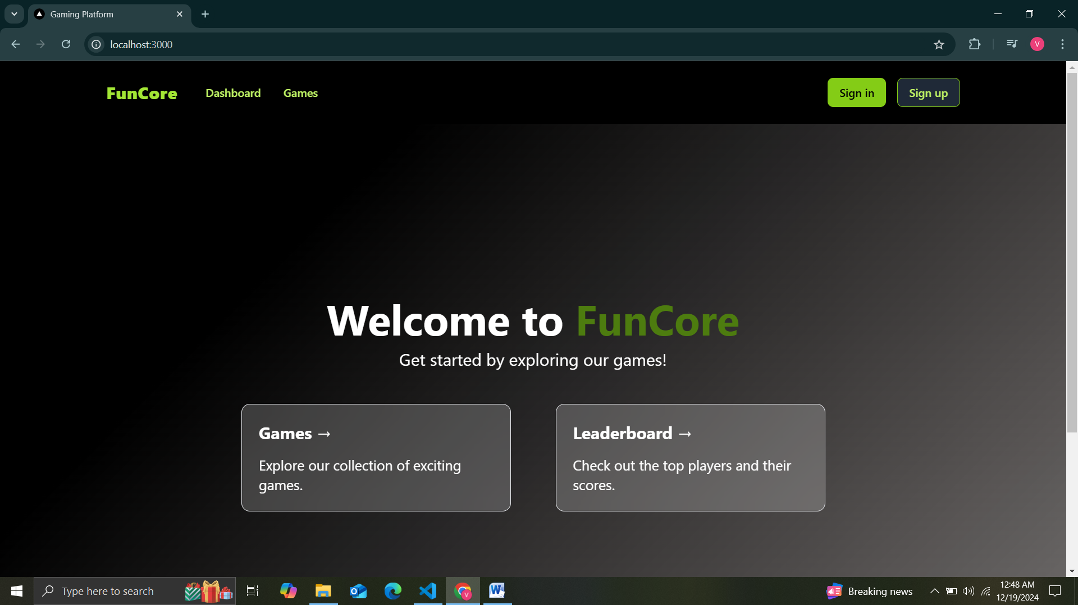

Figure 1 Home Page

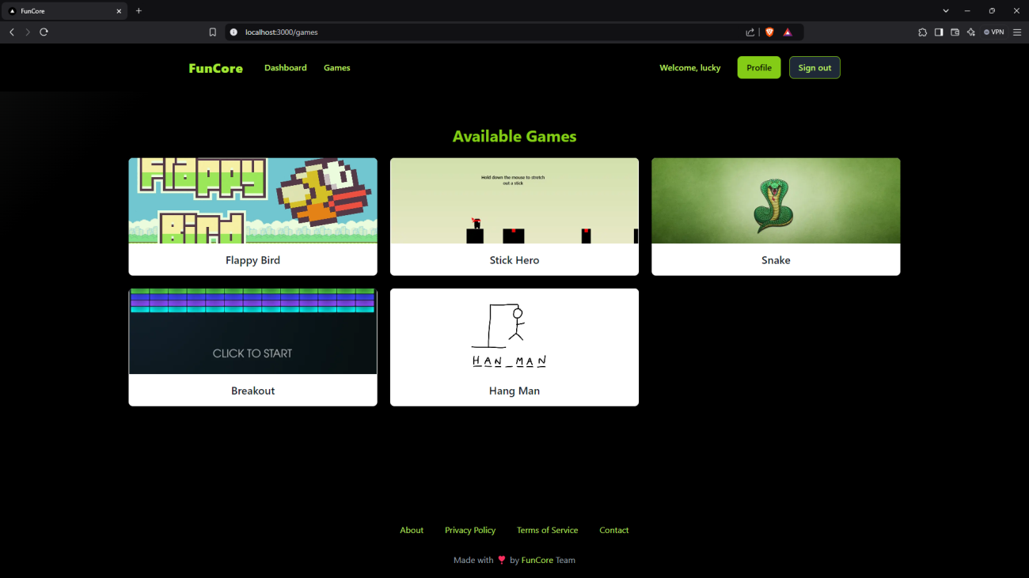

Figure 2- Dashboard

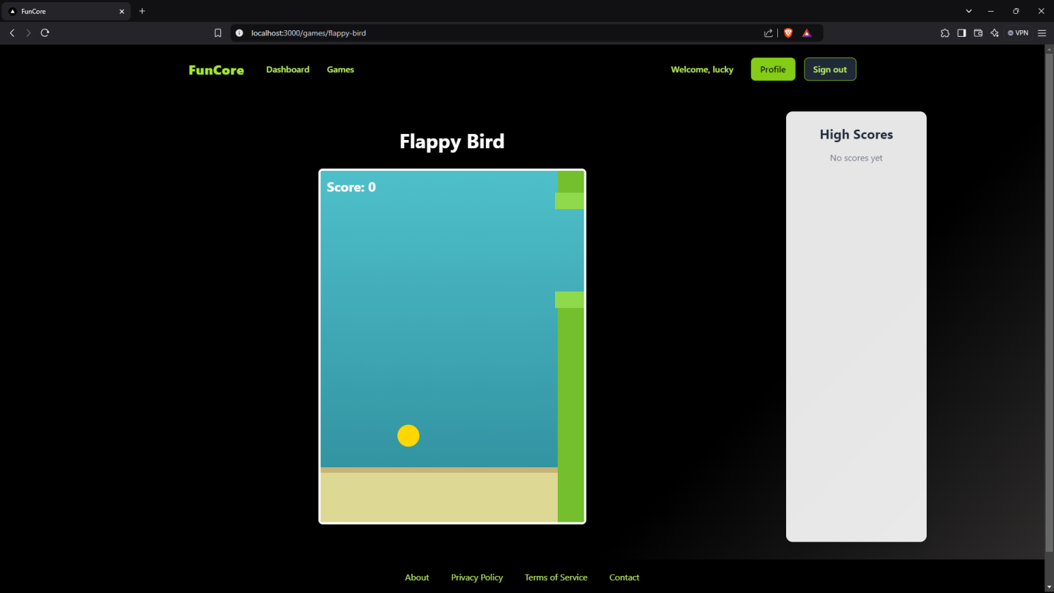

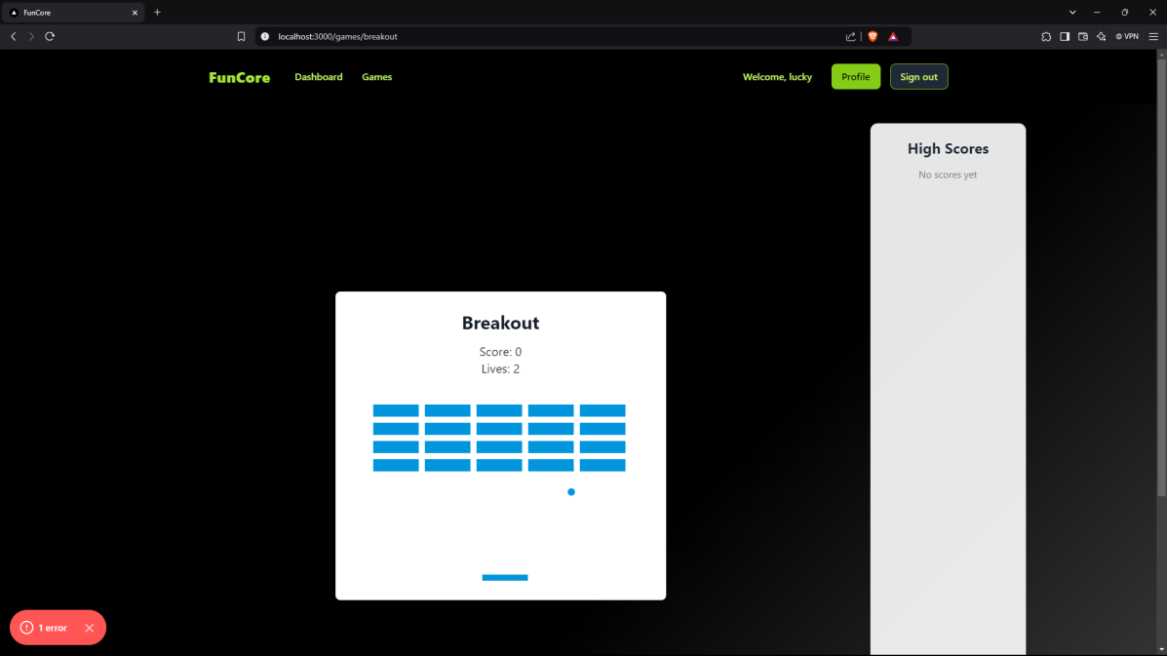

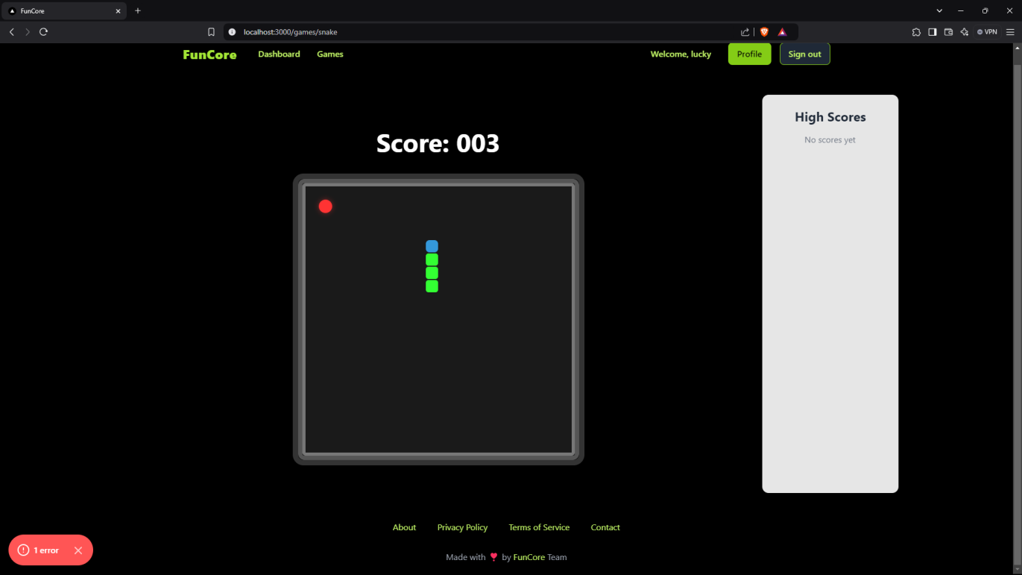

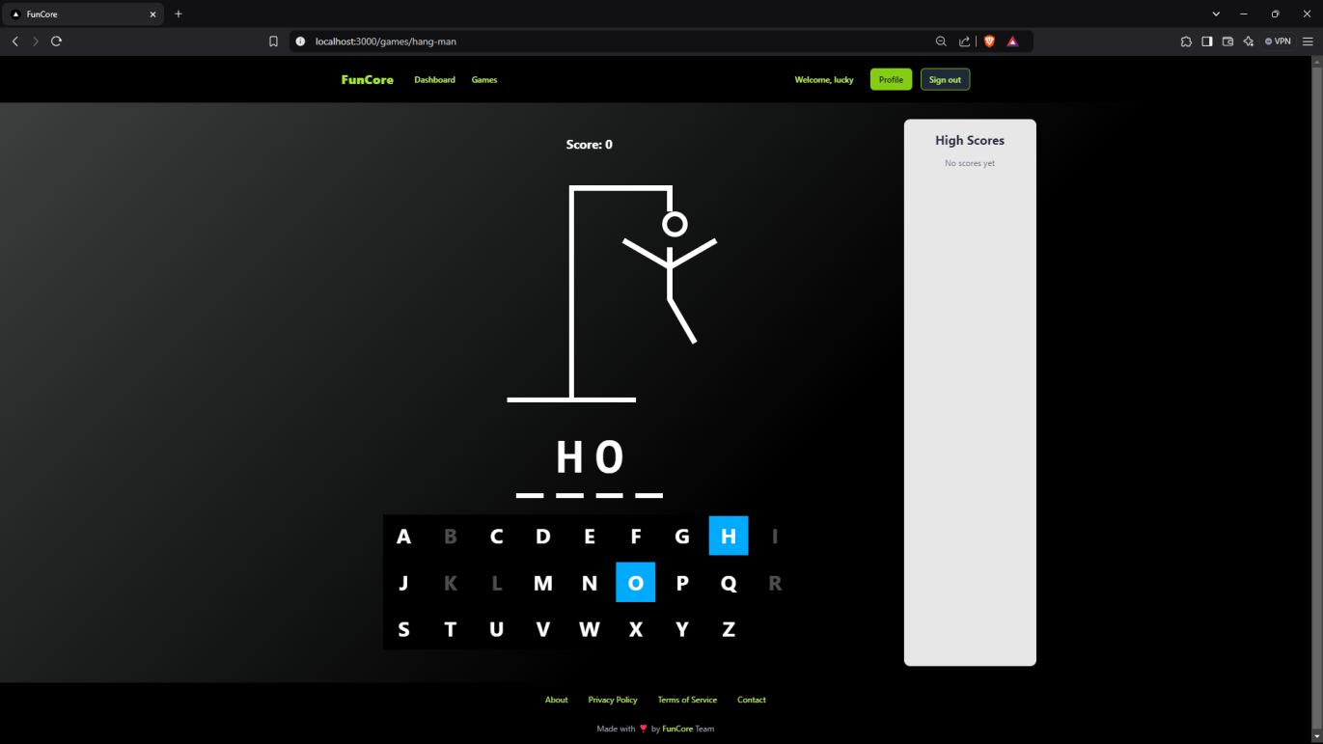

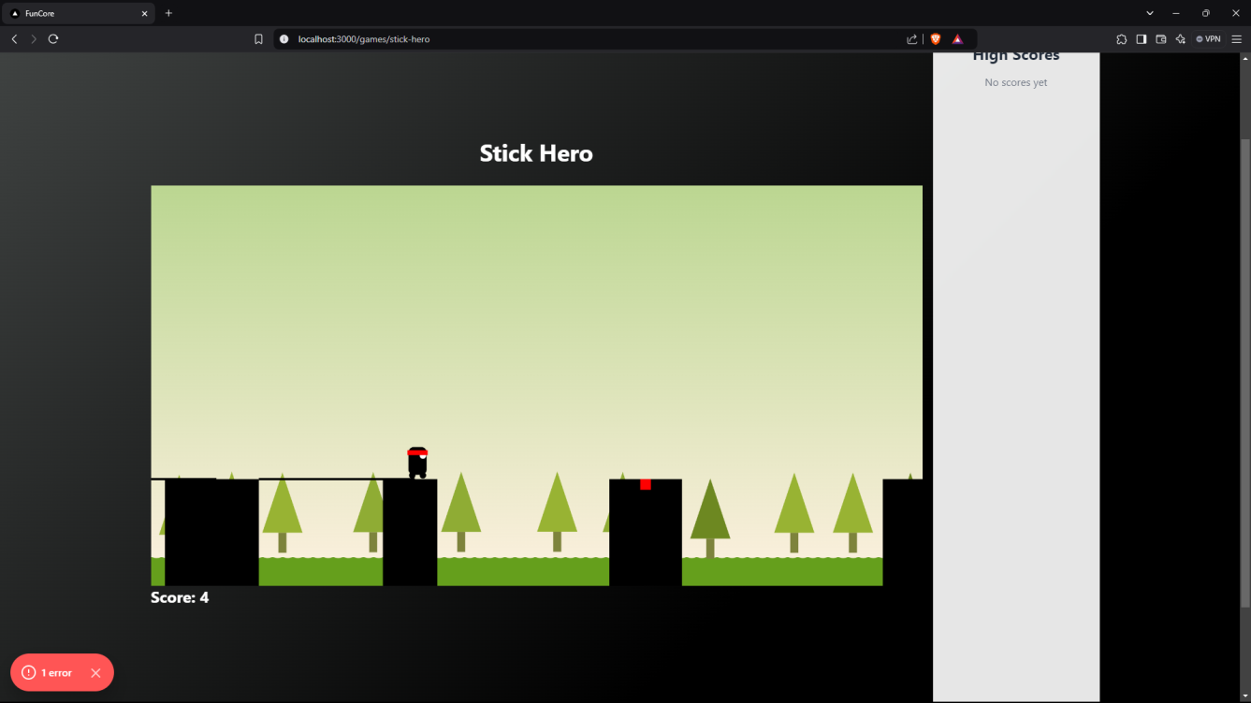

Figure 3- Games

**Chapter 5**

**Software Testing**

5.1 Introduction

Software testing is a vital part of the software development lifecycle (SDLC) to ensure that Funcore performs reliably, functions as intended, and delivers a high-quality user experience. This chapter outlines the testing methodologies, tools, and results used to validate the Funcore platform. The primary goal of testing is to identify and resolve any bugs, performance issues, and ensure that the system meets user requirements.

**5.2 Testing Objectives**

The key objectives of testing in **Funcore** are:

1. To verify the accuracy of course generation based on user inputs and selections.
2. To ensure the system generates quizzes, assignments, chapters, and other personalized learning content as expected.
3. To validate the customization features, such as adjusting chapter count and selecting additional resources (e.g., video links).
4. To ensure the user interface is intuitive, responsive, and offers a smooth user experience across all devices.
5. To ensure performance, security, and scalability of the platform for future growth and user demand.

**5.3 Testing Methodologies**

1. **Unit Testing**
   * **Objective**: To test individual modules or components of the system.
   * **Focus**:
     + Course parameter input validation (e.g., topic, difficulty, duration).
     + Customization features such as chapter count and video inclusion.
     + Integration with Gemini AI for accurate course generation.
   * **Tools Used**: Python unittest framework and manual testing.
2. **Integration Testing**
   * **Objective**: To test the interaction between different components of the system.
   * **Focus**:
     + Communication between the user input module and the course generation engine.
     + Seamless integration of quizzes and assignments into generated courses.
     + Validation of subscription management and its integration with course creation.
   * **Approach**: Bottom-up integration testing.
3. **System Testing**
   * **Objective**: To validate the entire **Funcore** platform against specified requirements.
   * **Focus**:
     + Accurate and structured course generation as per user inputs.
     + Full functionality of the customization options (e.g., chapter number, inclusion of resources).
     + Performance and reliability of the subscription model for limitless course generation.
   * **Environment**: Simulated production environment using cloud-based deployment tools.
4. **User Acceptance Testing (UAT)**
   * **Objective**: To ensure the platform meets user expectations and performs effectively in real-world scenarios.
   * **Focus**:
     + Usability and ease of navigation in the interface.
     + Accuracy and relevance of generated course content.
     + Smooth operation of subscription management and course limits.
   * **Process**: Testers and sample users provide real-world inputs to validate the platform’s behavior and user experience.

### **5.4 Test Cases**

### 

### **5.5 Results and Analysis**

After rigorous testing, the following outcomes were achieved:

1. **Accuracy**: The courses generated were perfectly aligned with user specifications, including topic, difficulty, and additional features such as quizzes and video resources.
2. **Performance**: The system responded efficiently, even with large and complex input datasets, ensuring minimal load times and smooth user experience.
3. **User Experience**: Testers confirmed that the user interface was intuitive and user-friendly, with easy navigation, real-time updates, and clear feedback messages.
4. **Scalability**: The subscription model worked seamlessly, allowing users to generate limitless courses after subscribing. The platform scaled well in a cloud-based environment, accommodating growth in user base and content generation needs.

**5.6 Conclusion**

The testing phase confirmed that **Funcore** functions accurately, reliably, and efficiently. By conducting unit, integration, system, and user acceptance testing, the platform was validated against real-world user inputs and requirements. The testing process ensured that **Funcore** is ready for deployment, offering a robust solution for personalized, AI-driven course generation.

The successful completion of this testing phase guarantees that **Funcore** provides a reliable, scalable, and user-friendly experience for course creators and learners, paving the way for further growth and continuous improvement.

**Chapter 6**

**Conclusion**

Software testing is a vital part of the software development lifecycle (SDLC) to ensure that Funcore performs reliably, functions as intended, and delivers a high-quality user experience. This chapter outlines the testing methodologies, tools, and results used to validate the Funcore platform. The primary goal of testing is to identify and resolve any bugs, performance issues, and ensure that the system meets user requirements.

**6.1 Key Achievements**  
The platform's core features and advantages include:

1. **Immersive Gameplay Experience:**

Funcore leverages advanced game engines like Phaser and PixiJS to create highly interactive and visually stunning 2D games. With responsive designs powered by Next.js and Tailwind CSS, the platform ensures a smooth and consistent gaming experience across all devices, including desktops, tablets, and mobile phones.

1. **Community Engagement and Competition:**

Funcore fosters a sense of community and competition through features such as leaderboards, achievements, and social sharing options. Players are encouraged to engage with friends, compare scores, and participate in challenges, driving both retention and user satisfaction.

1. **Educational Gaming Opportunities:**

In addition to entertainment, Funcore includes a library of educational games that enhance cognitive skills, creativity, and problem-solving. These games cater to students, parents, and educators, providing a value-added gaming experience that combines fun with learning.

1. **Secure Payment and Authentication Systems:**

The platform integrates Stripe for secure and seamless payment processing, enabling users to access premium features and games. Authentication is managed by Clerk, ensuring robust security and protecting user data.

1. **Data-Driven Optimization:**

Funcore uses MongoDB for efficient data storage and SQL-based analytics to track user behavior, preferences, and performance. These insights enable continuous optimization of games and platform features to enhance user satisfaction and engagement.

1. **Scalability and Future Expansion:**

Funcore's architecture is built for growth, with a backend powered by Node.js and a cloud-based infrastructure that supports increasing user demands without compromising performance. Plans for future enhancements include integrating 3D games with Three.js, adaptive controls, and user-friendly dashboards for players and administrators.

**6.2 Challenges Addressed**

* **User Retention and Engagement:** Funcore combats player fatigue with features that reward consistency, encourage social interaction, and offer varied game genres.
* **Cross-Platform Accessibility:** Ensuring smooth gameplay across devices through responsive designs and robust compatibility.
* **Data Security and Privacy:** Incorporating AES encryption, secure APIs, and role-based access control to safeguard user data and transactions.

**6.3 Future Prospects**  
Funcore aims to remain at the forefront of the gaming industry through several upcoming innovations:

* **Integration of 3D Gaming:** Utilizing Three.js for dynamic 3D game development to expand the platform's offerings.
* **Advanced Gamification Features:** Introducing adaptive challenges and dynamic leaderboards for personalized player experiences.
* **Global Reach:** Expanding the platform's accessibility by incorporating multilingual support and catering to diverse audiences.
* **Collaborative Ecosystem:** Enabling users to create and share custom game levels and content.

**6.4 Final Remarks**  
Funcore Gaming Platform represents a transformative approach to online gaming, delivering a seamless blend of entertainment, education, and community engagement. By combining cutting-edge technology with a focus on user experience, the platform offers an environment where players of all ages and interests can thrive.

Funcore's scalable infrastructure, secure systems, and commitment to innovation ensure its longevity and relevance in the evolving gaming industry. Its dual emphasis on fun and learning positions it as a versatile solution for both casual gamers and those seeking skill-building opportunities.

By addressing modern gamers' needs and setting ambitious goals for future development, Funcore is more than a platform—it's a vision for the future of gaming. With its dynamic features, robust architecture, and user-driven design, Funcore is poised to redefine how players engage with games, making it a leader in the global gaming ecosystem.

**Chapter 7**

**Summary**

The development of the Funcore Gaming Platform represents a forward-thinking approach to transforming online gaming. This chapter outlines the project's objectives, key features, and outcomes, showcasing the platform's potential to redefine gaming experiences by integrating entertainment, education, and user engagement.

**7.1 Overview of Objectives**  
The primary goal of Funcore was to create a robust, user-friendly gaming platform that leverages advanced technologies to provide an immersive, scalable, and engaging experience. Key objectives included:

1. **Delivering an Exceptional Gaming Experience**

Funcore focuses on providing users with visually appealing and interactive gameplay through cutting-edge tools like Phaser, PixiJS, and HTML Canvas. The aim is to combine smooth performance, intuitive controls, and captivating visuals to enhance user enjoyment.

1. **Enhancing User Engagement and Retention**

The platform integrates leaderboards, achievements, and performance tracking to foster competition and encourage frequent interaction. These features promote a sense of community and incentivize users to improve their skills and explore the platform consistently.

1. **Creating an Inclusive and Accessible Gaming Ecosystem**

Funcore ensures accessibility across all devices by employing responsive design techniques powered by Next.js and Tailwind CSS. The platform’s adaptability guarantees an optimal experience for users on desktops, tablets, and smartphones.

1. **Bridging Entertainment and Education**

Recognizing the potential of gamification in learning, Funcore incorporates educational games that enhance cognitive skills, creativity, and problem-solving, blending fun with skill development for users of all ages.

1. **Ensuring a Secure and Scalable Architecture**

Built on a robust Node.js backend and MongoDB database, Funcore is designed to support scalability and future growth. Secure authentication via Clerk and safe payment processing through Stripe provide users with a reliable and trustworthy platform.

**7.2 Highlights of Design and Features**  
Funcore combines innovative technology and user-focused design to deliver:

* **Visually Stunning and Interactive Games**: Featuring 2D and future 3D experiences with Phaser and Three.js.
* **User-Centric Features**: Leaderboards, adaptive controls, and personalized dashboards enhance engagement.
* **Data-Driven Insights**: Tools like SQL and MongoDB provide valuable analytics for optimization.
* **Seamless Payment Integration**: Secure premium content access through Stripe.

**7.3 Project Outcomes**  
Funcore has successfully achieved its objectives by:

* Delivering a scalable and visually rich gaming platform.
* Encouraging user engagement through community-focused features.
* Providing a bridge between entertainment and skill development.

**7.4 Challenges and Solutions**  
During development, several challenges were addressed:

* **Balancing Performance and Visual Quality**: Leveraging optimization techniques for seamless gameplay.
* **Ensuring Security**: Implementing advanced authentication and encryption to protect user data.
* **Adapting to Diverse Devices**: Ensuring consistency in performance across various platforms.

**7.5 Future Directions**  
Funcore’s roadmap includes:

* **3D Game Development**: Expanding the library with immersive gaming experiences using Three.js.
* **Adaptive Gaming Controls**: Customizing user interfaces based on individual preferences.
* **Advanced Analytics**: Enhancing gameplay and user engagement with data-driven improvements.

The development of the Funcore Gaming Platform underscores the importance of merging technology and user-centric design in the gaming industry. By addressing the needs of gamers and learners, Funcore contributes to the evolution of online gaming, offering a dynamic and versatile experience for all.

**Appendices**

**Appendix A: Glossary of Terms**

* **AI (Artificial Intelligence)**: The simulation of human intelligence by machines to perform tasks requiring cognitive abilities, such as natural language processing and data analysis.
* **RBAC (Role-Based Access Control)**: A method to restrict system access based on user roles within the platform.
* **AES (Advanced Encryption Standard)**: A secure encryption algorithm widely used to protect sensitive data.
* **API (Application Programming Interface)**: A set of tools and protocols enabling communication between different software components.
* **OAuth 2.0**: An authorization protocol allowing third-party services limited access to user data without sharing credentials.

**Appendix B: Technical Specifications**

**1. Programming Languages and Frameworks**

* **Frontend**: JavaScript, TypeScript, React.js, and Next.js.
* **Backend**: Node.js for server logic, Firebase for real-time database and authentication.
* **Database**: Schema management and queries handled using Drizzle ORM.

**2. Security Measures**

* **Encryption**: AES for data at rest and SSL/TLS protocols for data in transit.
* **Authentication**: Firebase Authentication with secure password hashing and token-based security.

**Appendix C: Development Tools and Resources**

**Tools**

* **IDE**: Visual Studio Code for coding and debugging.
* **Version Control**: Git (hosted on GitHub for repository management).
* **UI Design**: Figma for prototyping, wireframes, and mockups.

**Resources**

* **Online Tutorials**: Next.js and Tailwind CSS documentation for frontend development.
* **Community Support**: Forums like Stack Overflow and GitHub Discussions for troubleshooting and collaboration.

**Appendix D: Testing and Quality Assurance**

**1. Testing Types**

* **Unit Testing**: Verifies individual modules, including user inputs and AI integration.
* **Integration Testing**: Ensures seamless communication between components like AI, Firebase, and the frontend.
* **End-to-End Testing**: Simulates real-world user workflows to validate overall platform functionality.

**2. Testing Tools**

* **Jest**: For unit and integration tests.
* **Cypress**: For automated end-to-end testing to ensure a smooth user experience.

**Appendix E: Workflow and Team Roles**

**1. Team Roles**

* **Frontend Developer**: Builds and optimizes the platform's user interface.
* **Backend Developer**: Develops server-side logic and integrates the database.
* **UI/UX Designer**: Designs visually appealing and intuitive user interfaces.

**2. Workflow Tools**

* **Project Management**: Agile methodologies tracked using tools like Trello or Jira.
* **Team Communication**: Slack for daily updates, collaboration, and discussions.

**Appendix F: User Interface Mockups**

**Example Dashboard Design**

* **Components**:
  + User activity overview.
  + Progress tracker for ongoing courses.
  + Quick-access buttons for creating or editing courses.
* **Features**:
  + Drag-and-drop functionality in the course editor.
  + Widgets for easy addition of quizzes, videos, and assignments.